Diffusion
- State the definition of diffusion.

_____________________________________________________________________________
_____________________________________________________________________________
_____________________________________________________________________________

- State the definition of a concentration gradient.

_____________________________________________________________________________
_____________________________________________________________________________
_____________________________________________________________________________

- Decide if the rate of diffusion would be increased or decreased by making the following changes:

- Decreasing the temperature __________________
- Increasing the temperature __________________
- Increasing the surface area __________________
- Decreasing the surface area __________________
- Increasing the concentration gradient _______________
- Decreasing the concentration gradient ______________

- On to each of the diagrams below draw an arrow to indicate the direction of net movement of particles. Explain your answer using the terms high concentration and low concentration.
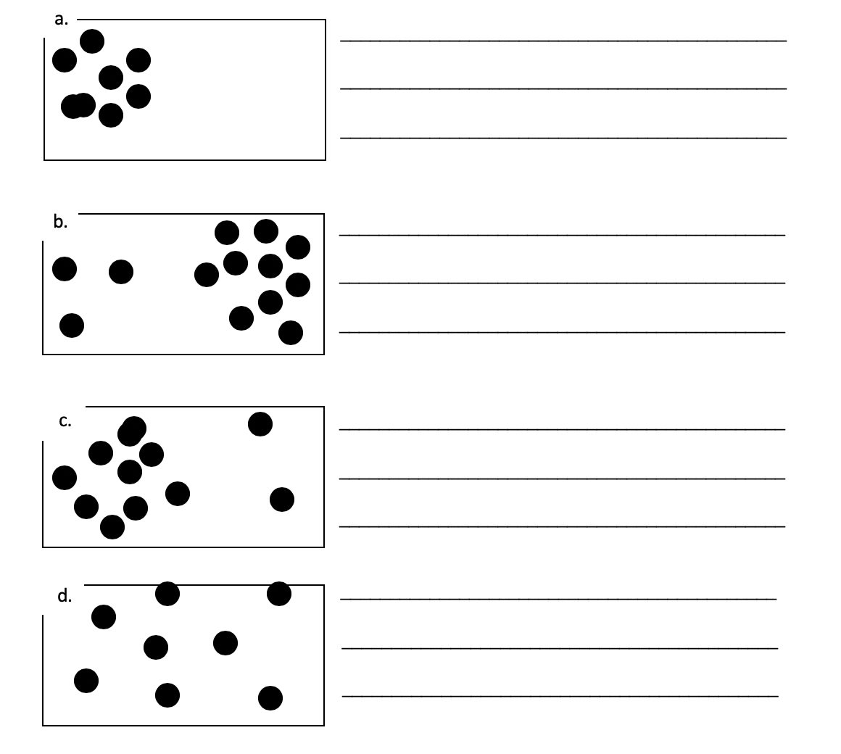

- Which of these would have a faster rate of diffusion? Explain your answer.
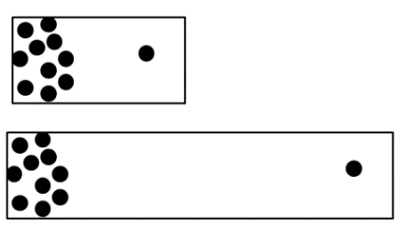
A

B

B

B

_____________________________________________________________________________
_____________________________________________________________________________
_____________________________________________________________________________
- Using your knowledge of particle theory explain why the rate of diffusion would be increased by increasing the temperature.

_____________________________________________________________________________
_____________________________________________________________________________
_____________________________________________________________________________

- Using your knowledge of particle theory explain why diffusion cannot happen in solids.

_____________________________________________________________________________
_____________________________________________________________________________
_____________________________________________________________________________

- Root hair cells are more effective at absorbing water than other types of plant cell. Explain why this is, using your knowledge of the structure of plant cells and root hair cells.

_____________________________________________________________________________
_____________________________________________________________________________
_____________________________________________________________________________

Stretch activity:

A scientist is trying to set a world record for the fastest rate of diffusion. Describe all the conditions that would be needed to allow this to happen.

